Date: April 2012
- This is the OMG submission template in Word and ODT. The OMG document number is pas/2012-04-08. The template was updated with a new Cover and Preface and supersedes OMG document pas/2008-10-01.

Specification Title

Version 1.x, 2.x.x, etc.

__________________________________________________
OMG Document Number: mars/2012-04-01
Normative reference: http://www.omg.org/spec/acronym/1.0/
Machine readable file(s): http://www.omg.org/acronym/20120401
Normative: http://www.omg.org/spec/acronym/20120401/foo.xmi
Non-normative: http://www.omg.org/spec/acronym/20120401/non_normative_foo.xmi
__________________________________________________

Sample: The machine readable file(s) URL 20120401 would be used when the schema file document numbers are ptc/12-04-14, ptc/2012-04-15, ptc/2012-04-16. If the machine readable files are in a .zip file, please list each file and URL in your Inventory report.

Copyright © 2008, company name
Copyright © 2008, Object Management Group, Inc.
Copyright © 2008, company name

USE OF SPECIFICATION - TERMS, CONDITIONS & NOTICES
The material in this document details an Object Management Group specification in accordance with the terms, conditions and notices set forth below. This document does not represent a commitment to implement any portion of this specification in any company's products. The information contained in this document is subject to change without notice.

LICENSES
The companies listed above have granted to the Object Management Group, Inc. (OMG) a nonexclusive, royalty-free, paid up, worldwide license to copy and distribute this document and to modify this document and distribute copies of the modified version. Each of the copyright holders listed above has agreed that no person shall be deemed to have infringed the copyright in the included material of any such copyright holder by reason of having used the specification set forth herein or having conformed any computer software to the specification.
Subject to all of the terms and conditions below, the owners of the copyright in this specification hereby grant you a fully-paid up, non-exclusive, nontransferable, perpetual, worldwide license (without the right to sublicense), to use this specification to create and distribute software and special purpose specifications that are based upon this specification, and to use, copy, and distribute this specification as provided under the Copyright Act; provided that: (1) both the copyright notice identified above and this permission notice appear on any copies of this specification; (2) the use of the specifications is for informational purposes and will not be copied or posted on any network computer or broadcast in any media and will not be otherwise resold or transferred for commercial purposes; and (3) no modifications are made to this specification. This limited permission automatically terminates without notice if you breach any of these terms or conditions. Upon termination, you will destroy immediately any copies of the specifications in your possession or control.

PATENTS
The attention of adopters is directed to the possibility that compliance with or adoption of OMG specifications may require use of an invention covered by patent rights. OMG shall not be responsible for identifying patents for which a license may be required by any OMG specification, or for conducting legal inquiries into the legal validity or scope of those patents that are brought to its attention. OMG specifications are prospective and advisory only. Prospective users are responsible for protecting themselves against liability for infringement of patents.

GENERAL USE RESTRICTIONS
Any unauthorized use of this specification may violate copyright laws, trademark laws, and communications regulations and statutes. This document contains information which is protected by copyright. All Rights Reserved. No part of this work covered by copyright herein may be reproduced or used in any form or by any means--graphic, electronic, or mechanical, including photocopying, recording, taping, or information storage and retrieval systems--without permission of the copyright owner.

DISCLAIMER OF WARRANTY

WHILE THIS PUBLICATION IS BELIEVED TO BE ACCURATE, IT IS PROVIDED "AS IS" AND MAY CONTAIN ERRORS OR MISPRINTS. THE OBJECT MANAGEMENT GROUP AND THE COMPANIES LISTED ABOVE MAKE NO WARRANTY OF ANY KIND, EXPRESS OR IMPLIED, WITH REGARD TO THIS PUBLICATION, INCLUDING BUT NOT LIMITED TO ANY WARRANTY OF TITLE OR OWNERSHIP, IMPLIED WARRANTY OF MERCHANTABILITY OR WARRANTY OF FITNESS FOR A PARTICULAR PURPOSE OR USE. IN NO EVENT SHALL THE OBJECT MANAGEMENT GROUP OR ANY OF THE COMPANIES LISTED ABOVE BE LIABLE FOR ERRORS CONTAINED HEREIN OR FOR DIRECT, INDIRECT, INCIDENTAL, SPECIAL, CONSEQUENTIAL, RELIANCE OR COVER DAMAGES, INCLUDING LOSS OF PROFITS, REVENUE, DATA OR USE, INCURRED BY ANY USER OR ANY THIRD PARTY IN CONNECTION WITH THE FURNISHING, PERFORMANCE, OR USE OF THIS MATERIAL, EVEN IF ADVISED OF THE POSSIBILITY OF SUCH DAMAGES.
The entire risk as to the quality and performance of software developed using this specification is borne by you. This disclaimer of warranty constitutes an essential part of the license granted to you to use this specification.

RESTRICTED RIGHTS LEGEND
Use, duplication or disclosure by the U.S. Government is subject to the restrictions set forth in subparagraph (c) (1) (ii) of The Rights in Technical Data and Computer Software Clause at DFARS 252.227-7013 or in subparagraph (c)(1) and (2) of the Commercial Computer Software - Restricted Rights clauses at 48 C.F.R. 52.227-19 or as specified in 48 C.F.R. 227-7202-2 of the DoD F.A.R. Supplement and its successors, or as specified in 48 C.F.R. 12.212 of the Federal Acquisition Regulations and its successors, as applicable. The specification copyright owners are as indicated above and may be contacted through the Object Management Group, 140 Kendrick Street, Needham, MA 02494, U.S.A.

TRADEMARKS
MDA®, Model Driven Architecture®, UML®, UML Cube logo®, OMG Logo®, CORBA® and XMI® are registered trademarks of the Object Management Group, Inc., and Object Management Group™, OMG™ , Unified Modeling Language™, Model Driven Architecture Logo™, Model Driven Architecture Diagram™, CORBA logos™, XMI Logo™, CWM™, CWM Logo™, IIOP™ , IMM™ , MOF™ , OMG Interface Definition Language (IDL)™ , and OMG SysML™ are trademarks of the Object Management Group. All other products or company names mentioned are used for identification purposes only, and may be trademarks of their respective owners.

COMPLIANCE
The copyright holders listed above acknowledge that the Object Management Group (acting itself or through its designees) is and shall at all times be the sole entity that may authorize developers, suppliers and sellers of computer software to use certification marks, trademarks or other special designations to indicate compliance with these materials.
Software developed under the terms of this license may claim compliance or conformance with this specification if and only if the software compliance is of a nature fully matching the applicable compliance points as stated in the specification. Software developed only partially matching the applicable compliance points may claim only that the software was based on this specification, but may not claim compliance or conformance with this specification. In the event that testing suites are implemented or approved by Object Management Group, Inc., software developed using this specification may claim compliance or conformance with the specification only if the software satisfactorily completes the testing suites.

OMG’s Issue Reporting Procedure

All OMG specifications are subject to continuous review and improvement. As part of this process we encourage readers to report any ambiguities, inconsistencies, or inaccuracies they may find by completing the Issue Reporting Form listed on the main web page http://www.omg.org, under Documents, Report a Bug/Issue (http://www.omg.org/technology/agreement.)

Table of Contents

1 Scope 1
2 Conformance 1
3 Normative References 1
4 Terms and Definitions 1
5 Symbols 2
6 Additional Information 2
7 Specification [chapter title] 3

Annex A 8
Annex B 9

Preface
OMG
Founded in 1989, the Object Management Group, Inc. (OMG) is an open membership, not-for-profit computer industry standards consortium that produces and maintains computer industry specifications for interoperable, portable, and reusable enterprise applications in distributed, heterogeneous environments. Membership includes Information Technology vendors, end users, government agencies, and academia.
OMG member companies write, adopt, and maintain its specifications following a mature, open process. OMG’s specifications implement the Model Driven Architecture® (MDA®), maximizing ROI through a full-lifecycle approach to enterprise integration that covers multiple operating systems, programming languages, middleware and networking infrastructures, and software development environments. OMG’s specifications include: UML® (Unified Modeling Language™); CORBA® (Common Object Request Broker Architecture); CWM™ (Common Warehouse Metamodel); and industry-specific standards for dozens of vertical markets.
More information on the OMG is available at http://www.omg.org/.
OMG Specifications
As noted, OMG specifications address middleware, modeling and vertical domain frameworks. All OMG Specifications are available from the OMG website at:
http://www.omg.org/spec
Specifications are organized by the following categories:
Business Modeling Specifications
Middleware Specifications
- CORBA/IIOP
- Data Distribution Services
- Specialized CORBA
IDL/Language Mapping Specifications
Modeling and Metadata Specifications
- UML, MOF, CWM, XMI
- UML Profile
Modernization Specifications
Platform Independent Model (PIM), Platform Specific Model (PSM), Interface Specifications
- CORBAServices
- CORBAFacilities
OMG Domain Specifications
CORBA Embedded Intelligence Specifications
CORBA Security Specifications
All of OMG’s formal specifications may be downloaded without charge from our website. (Products implementing OMG specifications are available from individual suppliers.) Copies of specifications, available in PostScript and PDF format, may be obtained from the Specifications Catalog cited above or by contacting the Object Management Group, Inc. at:

OMG Headquarters
140 Kendrick Street
Building A, Suite 300
Needham, MA 02494
USA
Tel: +1-781-444-0404
Fax: +1-781-444-0320
Email: pubs@omg.org
Certain OMG specifications are also available as ISO standards. Please consult http://www.iso.org
Typographical Conventions
The type styles shown below are used in this document to distinguish programming statements from ordinary English. However, these conventions are not used in tables or section headings where no distinction is necessary.
Times/Times New Roman - 10 pt.: Standard body text
Helvetica/Arial - 10 pt. Bold: OMG Interface Definition Language (OMG IDL) and syntax elements.
Courier - 10 pt. Bold: Programming language elements.
Helvetica/Arial - 10 pt: Exceptions

NOTE: Terms that appear in italics are defined in the glossary. Italic text also represents the name of a document, specification, or other publication.

Issues

The reader is encouraged to report any technical or editing issues/problems with this specification to http://www.omg.org/report_issue.htm.

Scope
The Scope clause shall appear at the beginning of each specification and define, without ambiguity, the subject of the specification and the aspect(s) covered. It indicates the limits of applicability of the specification or particular parts of it. It shall not contain requirements.
The scope shall be succinct so that it can be used as a summary for bibliographic purposes.
It shall be worded as a series of statements of fact.

Conformance
The Conformance clause identifies which clauses of the specification are mandatory (or conditionally mandatory) and which are optional in order for an implementation to claim conformance to the specification.
Note: For conditionally mandatory clauses, the conditions must, of course, be specified.

Normative References
The following normative documents contain provisions which, through reference in this text, constitute provisions of this specification. For dated references, subsequent amendments to, or revisions of, any of these publications do not apply.
List of normative references.

Terms and Definitions
For the purposes of this specification, the following terms and definitions apply.
Term
Definition
Term
Definition
Term
Definition

Symbols
List of symbols/abbreviations.

Additional Information

Changes to Adopted OMG Specifications [optional]
This specification completely replaces the xxx specification.

6.2 Acknowledgements
The following companies submitted this specification:
- xxxxx
- xxxxx
- xxxxx

The following companies supported this specification:
- xxxxx
- xxxxx
- xxxxx

Specification [chapter title]
This section presents the normative specification for the common infrastructure metamodel. It begins with an overview of the metamodel structure followed by a description of each sub-package.

7.1 Overview [sample Heading 2]
Text.

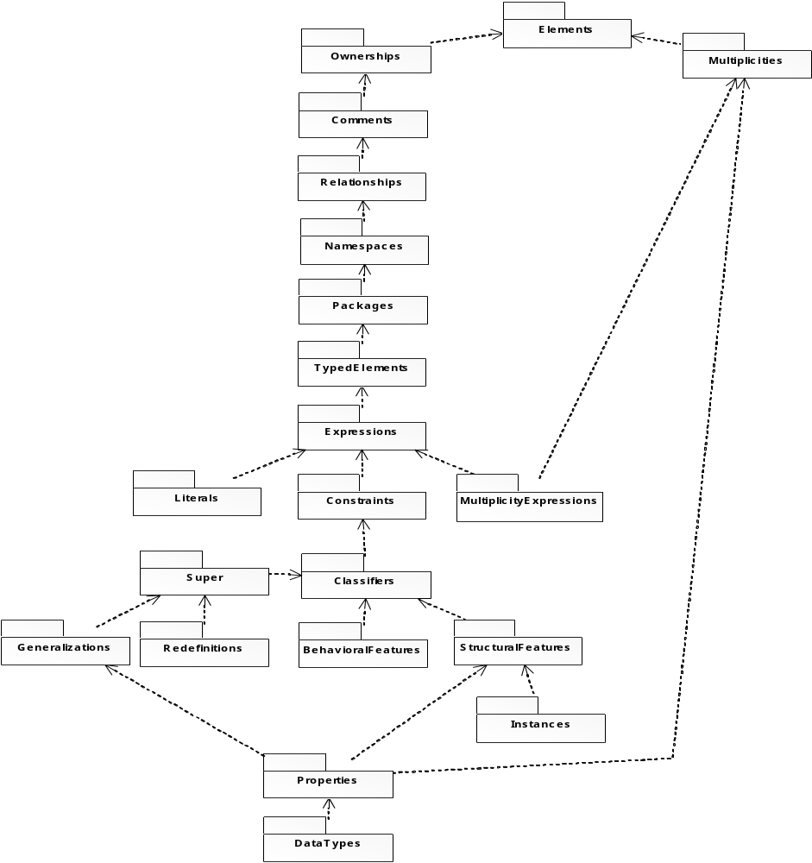

Figure 1 - figure title

7.1.1 Introduction [sample Heading 3]
Text

PrimitiveTypes [sample Heading 4]
Text.

Boolean

Package: PrimitiveTypes
isAbstract: No
Description
Boolean is an instance of PrimitiveType. In the metamodel, Boolean defines an enumeration that denotes a logical condition. Its enumeration literals are:
- true - Text
- false - Text

Comment

Package: Comments
isAbstract: No
Generalization: “Element”
Description
A comment is a textual annotation that can be attached to a set of elements. A comment gives the ability to attach various remarks to elements. A comment carries no semantic force, but may contain information that is useful to a modeler. A comment may be owned by any element. A Comment adds no semantics to the annotated elements, but may represent information useful to the reader of the model.
Attributes
body: String [0..1] | Specifies a string that is the comment.

Associations
annotatedElement : Element [*] | References the Element(s) being commented.

Element

Package: Comments
isAbstract: Yes
Generalization: “Element”
Description
An element can own comments. The comments for an Element add no semantics but may represent information useful to the reader of the model.
Associations
ownedComment : Comment [*] | The Comments owned by this element.  Subsets ownedElement

The Relationships subpackage of the Abstractions package adds support for directed relationships.

Condition Model [sample Heading 2]

Introduction [sample Heading 3]
Text.

Boolean ValueSpecification

Package: Condition Model
isAbstract: No
Generalization: “ValueSpecification”
Description
- Text
- Text
- Text

Text:
- Text
- Text

Sample footnotes:

Text and more text.

Table 1.
Package | Comment
Business Process Definition MetaModel | The Business Process Definition MetaModel package contains the models for orchestration (including BPMN) and choreography, and their performance, enactment, and execution. It has six subpackages grouped into two categories:  Common Behavior Model for the aspects of dynamics in common between orchestrations and choreography (Behavior Model, and Interactive Behavior Model).  Activity Model (including BPMN Extensions) for orchestration and Interaction Protocol Model for choreography.  The Business Process Definition MetaModel package imports the Common Infrastructure package which provides the framework that ties the other models to performance, enactment, and execution (Abstractions, Composition Model, Course Model, and Condition Model).
Common Infrastructure | The Common Abstractions package is the framework that ties the other models to performance, enactment, and execution (Composition Model, Course Model and Condition Model).

Annex A: Title

(normative)

A.1 Clause heading
Text
Normative annexes are integral parts of the standard. Their presence is optional. An annex’s normative status (as opposed to informative) shall be made clear by the way in which it is referred to in the text and under the heading of the annex.
Informative annexes give additional information intended to assist the understanding or use of the standard and shall not contain provisions to which it is necessary to conform in order to be able to claim compliance with the standard. Their presence is optional. An annex’s informative status (as opposed to normative) shall be made clear by the way in which it is referred to in the text and under the heading of the annex.

A.2 Clause heading
Text

Annex B: Title

(normative)

B.1 Sample IDL

#pragma prefix “http_//example.com"
module stockquote_wsdl {
interface StockQuotePortType {
typedef sequence<float> ArrayOfFloat;
typedef struct TimePeriod {
wstring startTime;
wstring endTime;
};
ArrayOfFloat GetTradePrices(
in wstring tickerSymbol,
in TimePeriod timePeriod,
out float frequency);
};
};

B.2 Sample Code

<?xml version="1.0"?>

<definitions name="StockQuote"
targetNamespace="http://example.com/stockquote.wsdl"
xmlns:tns="http://example.com/stockquote.wsdl"
xmlns:xsd="http://www.w3.org/2001/XMLSchema"
xmlns:xsd1="http://example.com/stockquote/schema"
xmlns="http://schemas.xmlsoap.org/wsdl/">

<types>
<schema targetNamespace="http://example.com/stockquote/schema"
xmlns:wsdl="http://schemas.xmlsoap.org/wsdl/"
xmlns="http://www.w3.org/2001/XMLSchema">
<complexType name="TimePeriod">
<all>
<element name="startTime" type="xsd:string"/>
<element name="endTime" type="xsd:string"/>
</all>
</complexType>
<complexType name="ArrayOfFloat">
<complexContent>
<restriction base="soapenc:Array">

Footnote text.
Footnote text.

